K.R. MANGALAM UNIVERSITY, GURUGRAM-122103

SCHOOL OF ENGENIERRING AND TECHNOLOGY

ASSIGNMENT 1

Data Analysis with Power BI & KNIME
ETMMML174


Department: SOET | Session: 2025-27
Program: MCA (AI & ML) | Semester: 1
Course Code: ETMMML174 | College Roll no: 2501940055
Course Name: Data Analysis with Power BI & KNIME
Submitted by: Tushar Singh | Faculty: Mr. Mohammad Aijaz

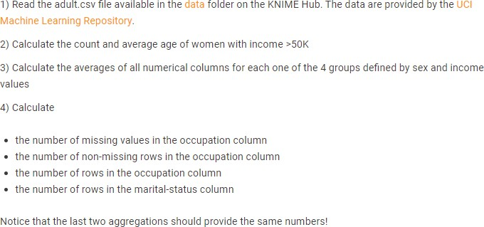

- Read the adult.csv file
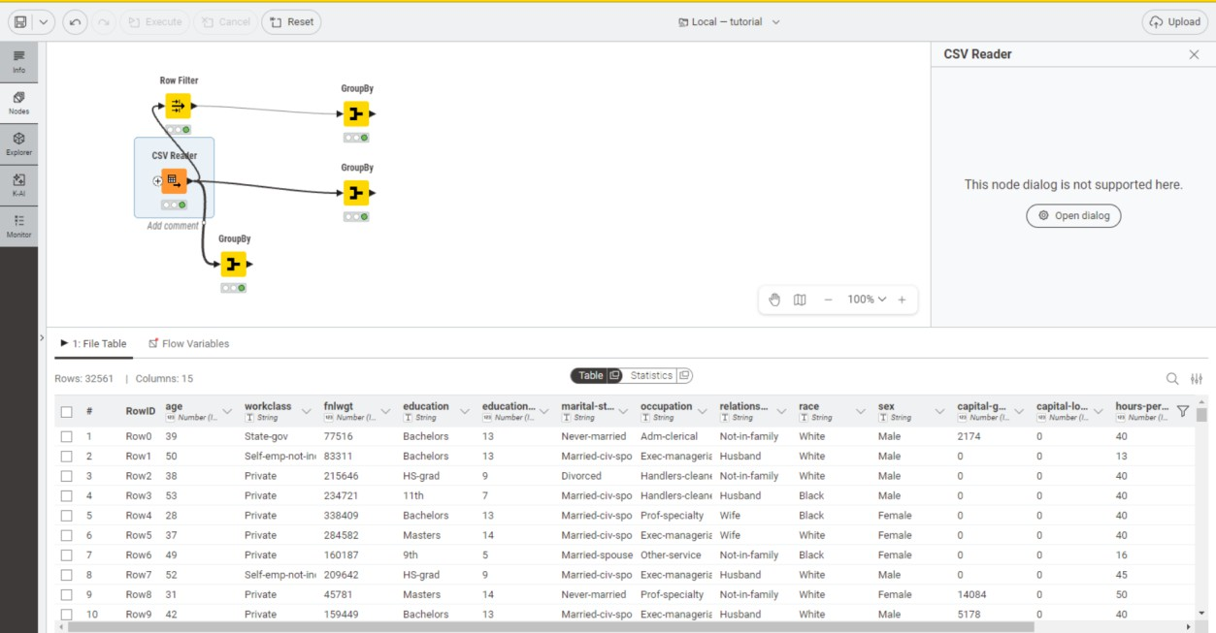

- A) Filter Female and Income >50k using Row Filter

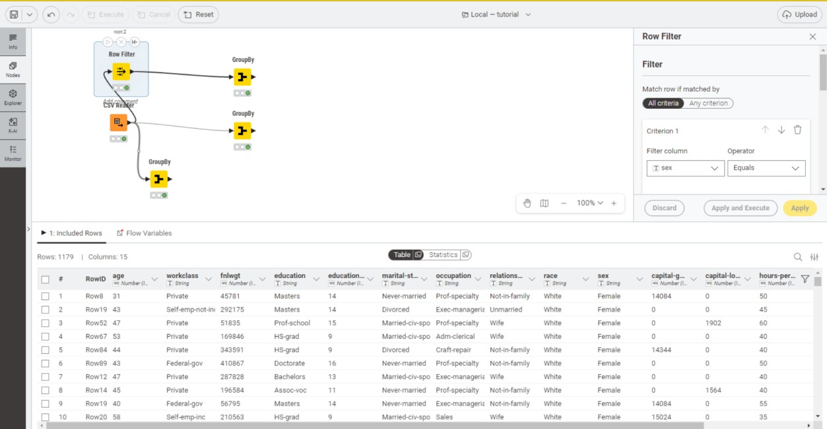
- B) Calculate the Count and Average age of women with income >50k
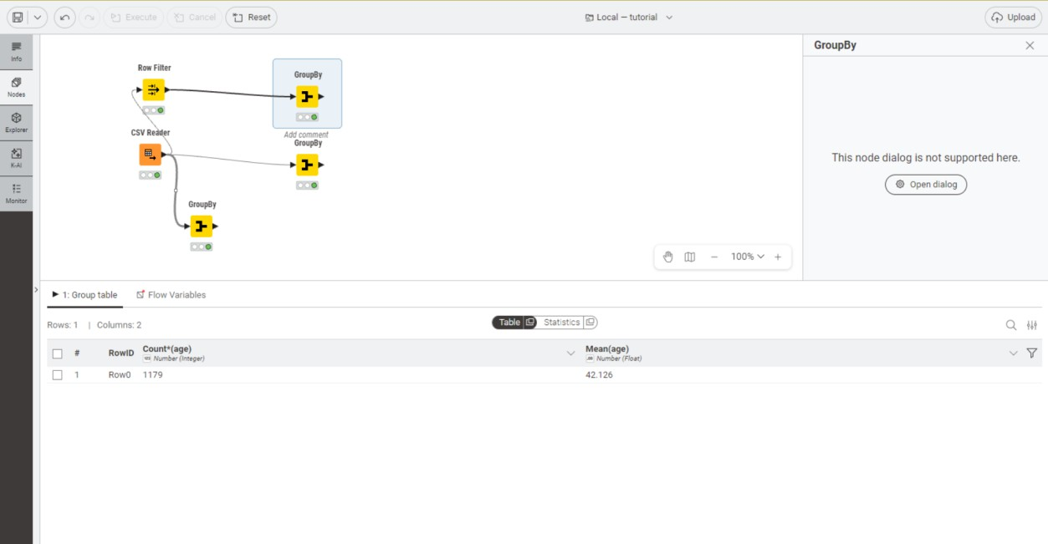

- Calculate the averages of all numerical columns for each one of the 4 groups defined by sex and income value

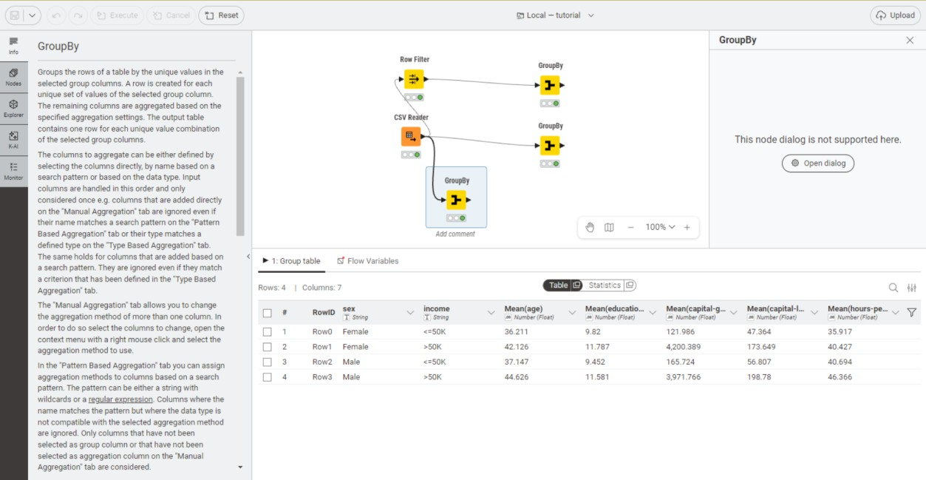
- Calculate:
  - the number of missing values in the occupation column
  - the number of non-missing rows in the occupation column
  - the number of rows in the occupation column
  - the number of rows in the marital-status column
